(A typical Specimen of Cover Page & Title Page)

<Font Style Times New Roman - Bold>

# **Impact of Gambling Addiction Games on the Mobile Gaming Market in India**

<Font Size 18> <1.5 line spacing>

A PROJECT REPORT [INTERNSHIP REPORT]

<Font Size 14>

#### Submitted by

<Font Size 14> <Italic>

Athul Ganesh.J [RA211105101003]

Nikhilesh Ram [RA2111051010016]

Immanuel Adaikala Russo [RA2111051010032]

Shyam Ganesh K [RA2111051010047]

<Font Size 16>

#### Under the Guidance of

<Font Size 14> <Italic>

## (Dr.SV. Shri Bharathi)

<Font Size 16>

(Assistant Professor, Data Science and Business Systems)

<Font Size 12>

### *in partial fulfillment of the requirements* *for the degree of*

<Font Size 14> <1.5 line spacing>

## BACHELOR OF TECHNOLOGY

## in

## COMPUTER SCIENCE ENGINEERING

## with specialization in (SPECIALIZATION NAME)

<Font Size 16>

## DEPARTMENT OF COMPUTATIONAL INTELLIGENCE COLLEGE OF ENGINEERING AND TECHNOLOGY

SRM INSTITUTE OF SCIENCE AND TECHNOLOGY

## KATTANKULATHUR- 603 203

<Font Size 16><l.5 line spacing>

### NOVEMBER 2024<Font Size 14>

Department of Computational Intelligence

##### SRM Institute of Science & Technology

##### Own Work* Declaration Form

This sheet must be filled in (each box ticked to show that the condition has been met). It must be signed and dated along with your student registration number and included with all assignments you submit – work will not be marked unless this is done.

To be completed by the student for all assessments

##### Degree/ Course : B.tech/CSE with specialization in Gaming Technology

**Student Name :Athul Ganesh**

##### Registration Number :RA2111051010003

**Title of Work : Impact of Gambling Addiction Games on the Mobile Gaming Market in India**

I / We hereby certify that this assessment compiles with the University’s Rules and Regulations relating to Academic misconduct and plagiarism**, as listed in the University Website, Regulations, and the Education Committee guidelines.

I / We confirm that all the work contained in this assessment is my / our own except where indicated, and that I / We have met the following conditions:

* Clearly referenced / listed all sources as appropriate
* Referenced and put in inverted commas all quoted text (from books, web, etc)
* Given the sources of all pictures, data etc. that are not my own
* Not made any use of the report(s) or essay(s) of any other student(s) either past or present
* Acknowledged in appropriate places any help that I have received from others (e.g. fellow students, technicians, statisticians, external sources)
* Compiled with any other plagiarism criteria specified in the Course handbook / University website

I understand that any false claim for this work will be penalized in accordance with the University policies and regulations.

|  |
| --- |
| **DECLARATION:** |
| I am aware of and understand the University’s policy on Academic misconduct and plagiarism and I certify that this assessment is my / our own work, except where indicated by referring, and that I have followed the good academic practices noted above. |
| If you are working in a group, please write your registration numbers and sign with the date for every student in your group. |

# Logo

# SRM INSTITUTE OF SCIENCE AND TECHNOLOGY KATTANKULATHUR – 603 203

<Font Style Times New Roman — Size - 18>

## BONAFIDE CERTIFICATE

<Font Style Times New Roman — Size - 16>

<Font Style Times New Roman — Size - 14>

Certified that 18CSP107L - Minor Project [18CSP108L- Internship] report titled “**Impact of Gambling Addiction Games on the Mobile Gaming Market in India** ” is the bonafide work of “ **Athul Ganesh.J [RA2111051010003] Nikhilesh Ram [RA2111051010016] Immanuel Adaikala Russo [RA2111051010032] Shyam Ganesh K [RA2111051010047]”** who carried out the project work[internship] under my supervision. Certified further, that to the best of my knowledge the work reported herein does not form any other project report or dissertation on the basis of which a degree or award was conferred on an earlier occasion on this or any other candidate.

<<Signature >> <<Signature >>

**SIGNATURE SIGNATURE**

##### <<Name >> DR. R. ANNIE UTHRA

|  |  |  |
| --- | --- | --- |
| **SUPERVISOR**  [Designation]  [Department] |  | **PROFESSOR &HEAD**  DEPARTMENT OF  COMPUTATIONAL INTELLIGENCE |

### Internship offer letter or completion letter for internship students only

**ACKNOWLEDGEMENTS**

We express our humble gratitude to **Dr. C. Muthamizhchelvan**, Vice-Chancellor, SRM InstituteofScience and Technology, for the facilities extended for the project work and his continued support.

We extend our sincere thanks to **Dr. T. V. Gopal ,** Dean-CET, SRM Institute of Science and Technology, for his invaluable support.

We wish to thank **Dr. Revathi Venkataraman**, Professor and Chairperson, School of Com puting, SRM Institute of Science and Technology, for her support throughout the project work.

We encompass our sincere thanks to , **Dr. M. Pushpalatha**, Professor and Associate Chairperson, School of Computing and **Dr. C.Lakshmi,** Professor and Associate Chairperson, School of Computing, SRM Institute of Science and Technology, for their invaluable support.

We are incredibly grateful to our Head of the Department, **Dr. R. Annie Uthra**, Professor, Department of Computational Intelligence, SRM Institute of Science and Technology, for her suggestions and encouragement at all the stages of the project work.

We want to convey our thanks to our Project Coordinators, ........., Panel Head, ......... and Panel Members, .........., Department of Computational Intelligence, SRM Institute of Science and Technology, for their inputs during the project reviews and support.

We register our immeasurable thanks to our Faculty Advisor, ..................., Department of Computational Intelligence, SRM Institute of Science and Technology, for leading and helping us to complete our course.

Our inexpressible respect and thanks to our guide, ....................., Department of Computational Intelligence, SRM Institute of Science and Technology, for providing us with an opportunity to pursue our project under his / her mentorship. He / She provided us with the freedom and support to explore the research topics of our interest. His / Her passion for solving problems and making a difference in the world has always been inspiring.

We sincerely thank all the staff and students of Computational Intelligence, School of Computing, S.R.M Institute of Science and Technology, for their help during our project. Finally, we would like to thank our parents, family members, and friends for their unconditional love, constant support and encouragement

Authors

### **ABSTRACT**

### The mobile gaming market in India has seen exponential growth over the past decade, driven by the proliferation of affordable smartphones and widespread internet access. However, the rise of mobile gambling, which often coexists with mobile gaming, has introduced significant challenges. This paper explores the impact of gambling addiction on the mobile gaming market in India, examining how the convergence of gaming and gambling affects consumer behavior, market perception, and regulatory frameworks.

**TABLE OF CONTENTS**

**ABSTRACT v**

**TABLE OF CONTENTS vi**

**LIST OF FIGURES vii**

**LIST OF TABLES viii**

**ABBREVIATIONS ix**

**CHAPTER NO. TITLE PAGE NO.**

**1 INTRODUCTION 1**

1.1 General (Introduction to Project) 2

1.2 Motivation 3

1.3 Sustainable Development Goal of the Project 4 1.4 Product Vision Statement 5

1.5 Product Goal 6

1.6 Product Backlog (Key User Stories with Desired Outcomes) 7

1.7 Product Release Plan 8

**2 SPRINT PLANNING AND EXECUTION 9**

**2.1 Sprint 1 10** 2.1.1 Sprint Goal with User Stories of Sprint 1 11

2.1.2 Functional Document 12

2.1.3 Architecture Document 13

2.1.4 UI Design 14

2.1.5 Functional Test Cases 15

2.1.6 Daily Call Progress 16

2.1.7 Committed vs Completed User Stories 17

2.1.8 Sprint Retrospective 18

**2.2 Sprint 2 19**

2.2.1 Sprint Goal with User Stories of Sprint 2 20

2.2.2 Functional Document 21

2.2.3 Architecture Document 22

2.2.4 UI Design 23

2.2.5 Functional Test Cases 24

2.2.6 Daily Call Progress 25

2.2.7 Committed vs Completed User Stories 26

2.2.8 Sprint Retrospective 27

**2.3 Sprint 3 28**

2.3.1 Sprint Goal with User Stories of Sprint 3 29

2.3.2 Functional Document 30

2.3.3 Architecture Document 31

2.3.4 UI Design 32

2.3.5 Functional Test Cases 33

2.3.6 Daily Call Progress 34

2.3.7 Committed vs Completed User Stories 35

2.3.8 Sprint Retrospective 36

**3.** **RESULTS AND DISCUSSIONS 37**

3.1 Project Outcomes (Justification of outcomes and how they align 38

with the goals)

3.2 Committed vs Completed User Stories 39

**4 CONCLUSIONS & FUTURE ENHANCEMENT 40**

**APPENDIX**

**A. PATENT DISCLOSURE FORM**

**B. SAMPLE CODING**

**C. PLAGIARISM REPORT**

**LIST OF FIGURES**

**CHAPTER NO TITLE PAGE NO.**

**1**  1.1 General (Introduction to Project) 1

**The Indian mobile gaming industry is projected to grow rapidly, with estimates suggesting it could become a $5 billion market by 2025. However, the growth of mobile gambling alongside this industry raises concerns about the potential for gambling addiction to negatively impact the broader gaming market. As mobile gambling becomes more accessible, it also becomes more addictive, leading to public health concerns and potential backlash against the industry as a whole.**

**LIST OF TABLES**

**CHAPTER NO TITLE PAGE NO.**

**1** 1.2 Motivation 2

**Gambling addiction leads to a negative public perception of mobile games that incorporate gambling elements. This stigmatization can reduce user trust and engagement, thereby impacting the overall market. In India, where mobile gaming is a relatively new phenomenon, maintaining a positive market image is crucial for continued growth.**

**ABBREVIATIONS**

**CHAPTER 1**

**INTRODUCTION**

**1.1 Introduction to Ai E-learning Application:**

**The Indian mobile gaming industry is projected to grow rapidly, with estimates suggesting it could become a $5 billion market by 2025. However, the growth of mobile gambling alongside this industry raises concerns about the potential for gambling addiction to negatively impact the broader gaming market. As mobile gambling becomes more accessible, it also becomes more addictive, leading to public health concerns and potential backlash against the industry as a whole**

**1.2 Motivation**

**Gambling addiction leads to a negative public perception of mobile games that incorporate gambling elements. This stigmatization can reduce user trust and engagement, thereby impacting the overall market. In India, where mobile gaming is a relatively new phenomenon, maintaining a positive market image is crucial for continued growth.**

**1.3 Sustainable Development Goal of the Project**

* Conduct research on mobile gambling addiction, including its causes, triggers, and effects on individuals.
* Define Features: Decide on the core features of the app lock. Common features might include:
* Blocking access to gambling apps and websites.
* Time-based restrictions (e.g., limiting usage during specific hours).
* Password protection or biometric lock.
* Notifications and alerts to discourage gambling.
* Integration with support systems like hotlines or therapy services.
* Legal Considerations: Ensure that your app complies with local and international laws, particularly around user privacy and app permissions.

.

**1.4 Product Vision Statement**

**1.4.1. Audience:**

* **Primary Audience: Individuals aiming to limit their gambling habits and improve digital wellbeing.**
* **Secondary Audience: Family members, guardians, and therapists interested in supporting safe device use through app monitoring and restriction features.**

**1.4.2. Needs:**

* **Primary Needs:**
  + **Effective and secure locking mechanisms for gambling applications.**
  + **Real-time notifications and monitoring features to track access attempts.**
  + **User-friendly setup for managing app locks and tracking device usage patterns.**
* **Secondary Needs:**
  + **Detailed logging and reporting tools to help users review their progress.**
  + **Customizable settings for managing access to multiple apps.**
  + **Support for user preferences in lock options, notifications, and usage tracking.**

**1.4.3. Products:**

* **Core Product: An addiction management tool providing app detection, locking, access tracking, and notifications focused on gambling apps.**
* **Additional Features:**
  + **Customizable lock mechanisms, including PIN, pattern, and biometric authentication.**
  + **Configurable notifications to alert users of any app access attempts.**
  + **Reporting features that allow users to review access history for each locked app.**

**1.4.4. Values:**

* **Core Values:**
  + **Control: Enabling users to manage their app usage and mitigate addiction risks.**
  + **Security: Ensuring user data is private and secure with reliable authentication methods.**
  + **Awareness: Helping users build awareness of their habits through real-time tracking and notifications.**
* **Differentiators:**
  + **Customizable App Locking: Providing flexible lock options tailored to user needs.**
  + **Real-Time Access Monitoring: Immediate notifications for access attempts.**
  + **Progress Tracking: Offering detailed reports to support users’ efforts in maintaining healthier device habits.**
  1. **Product Goal**

The primary goal of the App Lock project is to empower individuals to manage their gambling app usage proactively and responsibly. By offering secure and customizable app-locking, real-time monitoring, and insightful usage tracking, the app provides users with the tools to limit access to gambling applications and build healthier digital habits. Designed to support addiction management and foster digital wellbeing, the App Lock app aims to create a safe and supportive environment where users can regain control over their app usage. Ultimately, this product aspires to contribute to a healthier relationship between users and their devices by promoting self-awareness, reducing compulsive behavior, and enhancing overall mental health..

**1.6 Product Backlog**

|  |  |
| --- | --- |
| **S.No** | **User Stories of AI E-Learning Application** |
| #US 1 | As a new user, I want an easy registration process to access the app lock features for managing gambling app usage. |
| #US 2 | As a new user, I want to create a secure profile after registration so that I can customize my app locking and tracking settings. |
| #US 3 | As a user, I want the app to automatically detect gambling applications on my device so that I can quickly identify and lock them |
| #US 4 | As a user, I want to lock specific gambling apps using various methods (PIN, pattern, biometric) to prevent unauthorized access. |
| #US 5 | As a user, I want real-time notifications whenever a locked app is accessed, so I can stay aware of my usage habits. |
| #US 6 | As a user, I want to view a history of access attempts, including successful and failed logins, to monitor my app interactions. |
| #US 7 | As a user, I want to configure the app to automatically re-lock gambling apps after a period of inactivity to ensure continuous protection. |
| #US 8 | As a user, I want daily and weekly reports on my app usage to track my progress and gain insights into my habits. |
| #US 9 | As a user, I want the ability to set reminders for the locked apps, helping me manage my time and prevent compulsive access |
| #US 10 | As a user, I want to customize the type and frequency of notifications so that I receive only relevant alerts. |
| #US 11 | As a user, I want to provide feedback on the app’s features and usability to help improve its functionality and user experience. |

This backlog captures key user stories for the App Lock project, emphasizing usability, security, and habit-tracking features. Let me know if you'd like to add or adjust any item

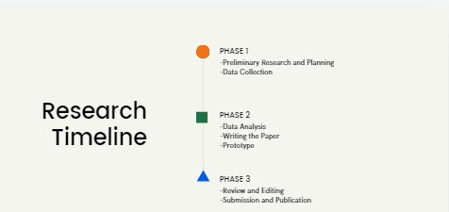

.f igure 1.1 MS Planner Board of App lock Application

**1.7 Product Release Plan**

The following Figure 1.2 depicts the release plan of the project

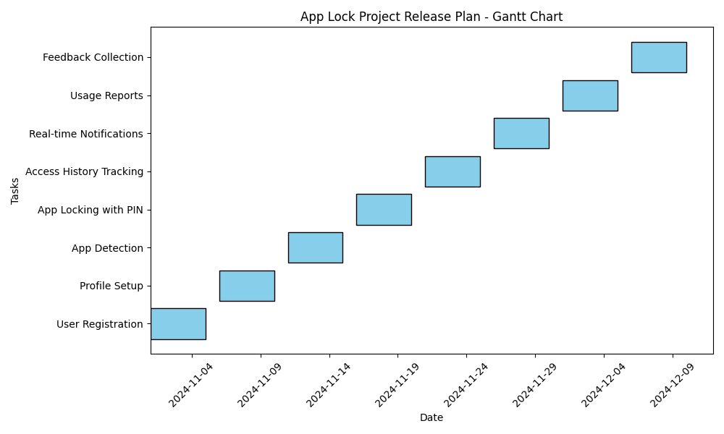

Figure 1.2 Release plan of App-LockApplication

**CHAPTER 2**

**SPRINT PLANNING AND EXECUTION**

**2.1 Sprint 1**

**2.1.1 Sprint Goal with User Stories of Sprint 1**

**The goal of the first sprint is to create the user registration and authentication system, and to enable initial functionalities such as app detection for identifying gambling apps on the user’s device.**

**Table 2.1 Detailed User Stories of sprint 1**

|  |  |
| --- | --- |
| **S.NO** | **Detailed User Stories** |
| US #1 | As a new user, I want to register securely on the app so that I can access the app lock features |
| US #2 | As a new user, I want to set up a secure profile with authentication (PIN, pattern, or biometric) so that my settings are protected. |
| US #3 | As a user, I want the app to automatically detect installed gambling apps so that I can choose which apps to monitor and lock. |

Planner Board representation of user stories are mentioned below figures 2.1,2.2 and 2.3

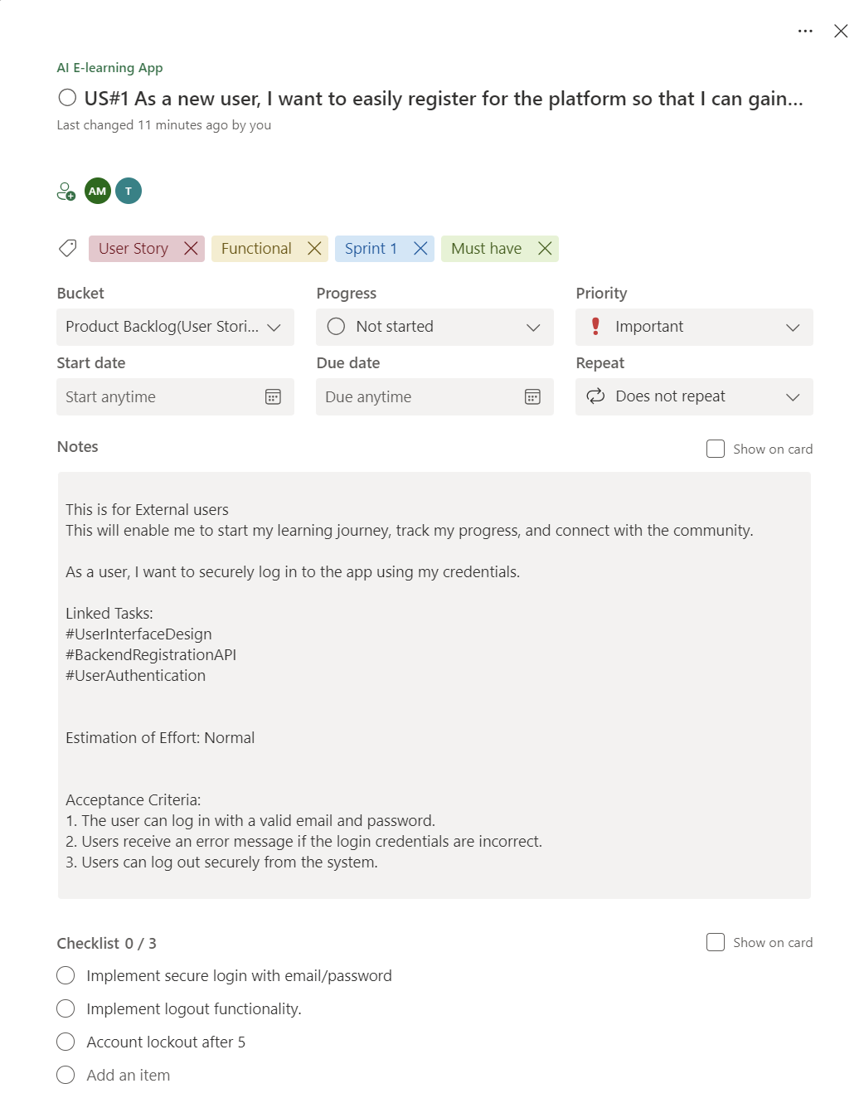

Figure 2.1 user story for user registration

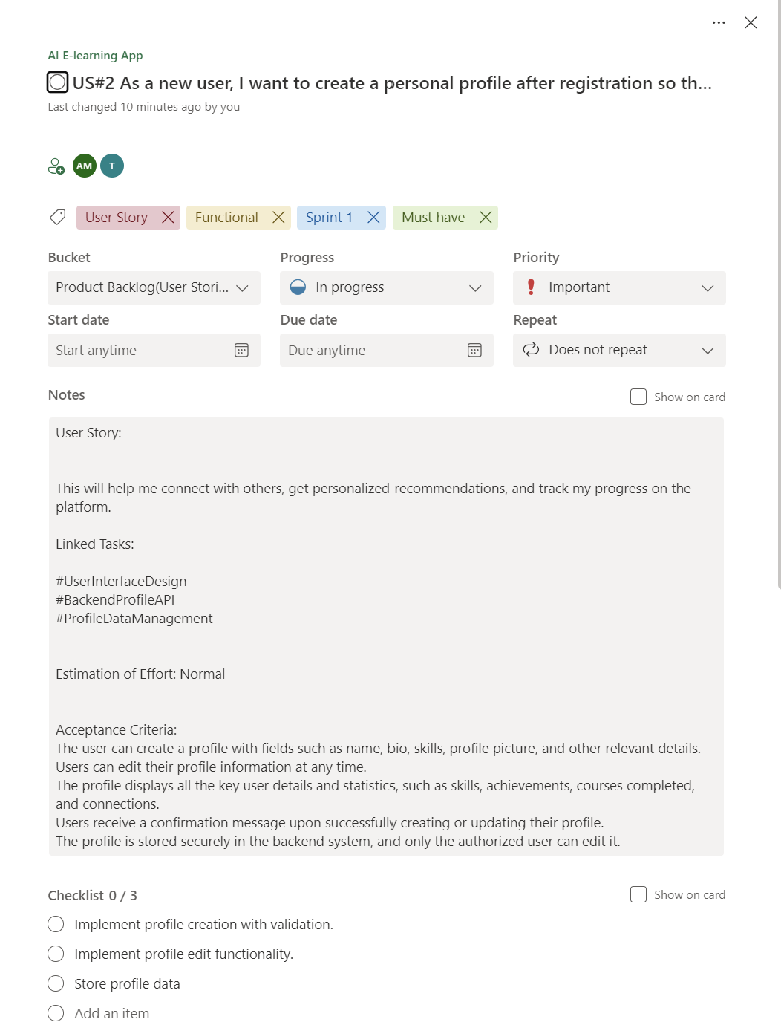

Figure 2.2 user story for profile creation

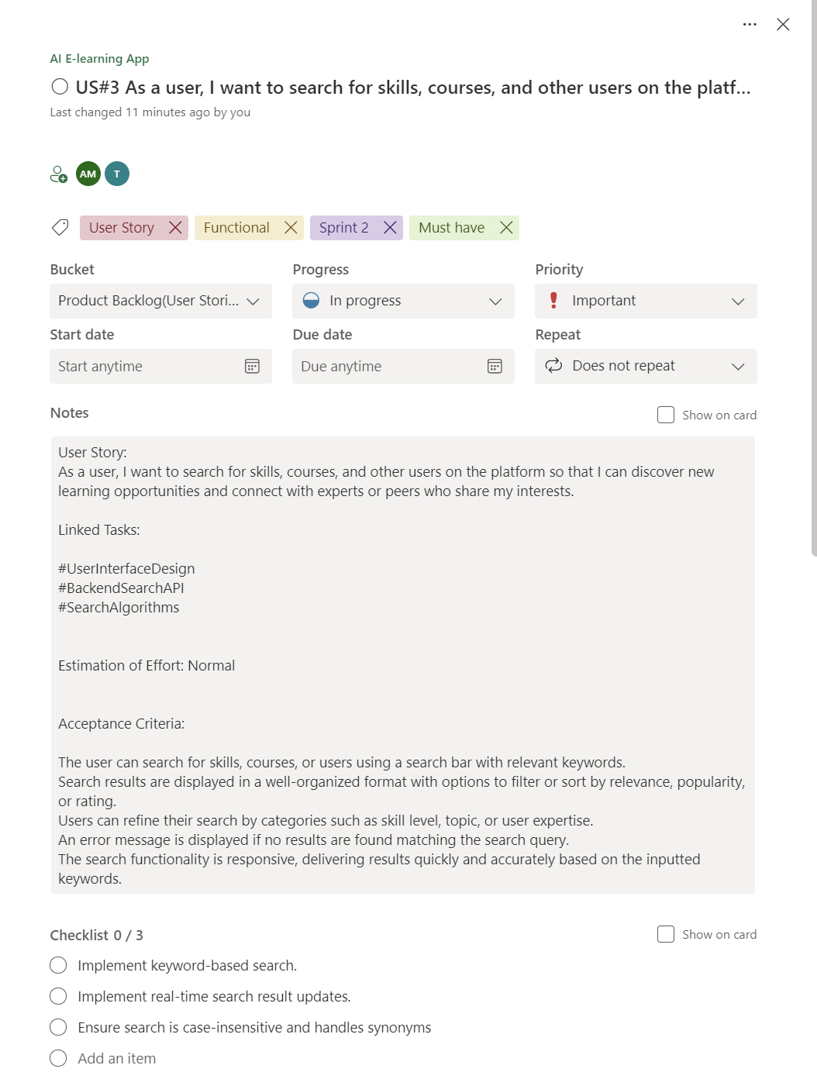

Figure 2.3 User story for search functionality

**2.1.2 Functional Document**

**2.1.2.1. Introduction**

The App Lock project aims to provide a user-focused platform that helps individuals manage gambling app usage effectively. This project focuses on delivering a secure, customizable app-locking experience, enabling real-time monitoring and notifications, and fostering a healthier digital lifestyle. The App Lock platform is designed to address the needs of users seeking to reduce or control their gambling habits through accessible, user-friendly features.

**2.1.2.2. Product Goal**

The primary goal of this project is to develop an app that empowers users to control their gambling app usage by locking selected apps, tracking usage patterns, and providing real-time notifications. The App Lock platform aims to:

* Provide secure, customizable app-locking options to restrict access to gambling apps.
* Enable real-time access monitoring and notifications for usage awareness.
* Offer insightful reports on app usage to promote self-awareness and support behavior change.
* Enhance user privacy and security with robust authentication methods.

**2.1.2.3. Demography (Users, Location)**

**Users:**

* **Target Users**: Individuals seeking to control gambling habits, parents/guardians, and therapists.
* **User Characteristics**: Varied technical proficiency levels, diverse demographics, primarily those who wish to monitor and control app usage habits for themselves or loved ones.

**Location:**

* **Target Location**: Global, with emphasis on regions with high internet penetration and where gambling is prevalent, making the app beneficial for a broad audience seeking digital wellbeing solutions.

**2.1.2.4. Business Processes**

The key business processes include:

**User Registration and Authentication:**

* **Description**: Users can securely register and authenticate using email or phone-based methods, including options for PIN, pattern, or biometric access.
* **Purpose**: Authentication ensures that only authorized users can access the app’s locking features and view usage reports.

**App Detection and Locking:**

* **Description**: The app detects installed gambling applications and allows users to select which apps to lock.
* **Purpose**: Provides users with a simple and effective way to control their access to selected gambling apps.

**2.1.2.5. Features**

This project focuses on implementing the following key features:

**Feature 1: User Registration and Profile Setup**

1. **Description**:
   * The app allows new users to register and set up a secure profile with a preferred authentication method, including PIN, pattern, or biometric lock.
2. **User Story**:
   * *As a new user, I want to register and secure my profile so that I can access the app lock features safely.*

**Feature 2: App Detection and Locking**

1. **Description**:
   * The app automatically detects installed gambling apps on the user’s device, providing a list from which users can select apps to lock.
2. **User Story**:
   * *As a user, I want the app to detect gambling apps on my device so that I can easily choose which ones to lock.*

**Feature 3: Real-time Access Notifications**

1. **Description**:
   * The app provides real-time notifications for any access attempt on locked gambling apps, helping users stay aware of their interactions.
2. **User Story**:
   * *As a user, I want real-time notifications for access attempts on locked apps so that I am immediately informed of any usage.*

**Feature 4: Access History and Usage Reports**

1. **Description**:
   * Users can view a history of app access attempts and usage reports, showing patterns and helping them monitor their behavior over time.
2. **User Story**:
   * *As a user, I want to view usage reports to understand my interaction with gambling apps and support my efforts to control usage.*

**Feature 5: Customizable Lock and Notification Settings**

1. **Description**:
   * Users can customize lock options (e.g., automatic re-lock after inactivity) and notification preferences to tailor the app to their needs.
2. **User Story**:
   * *As a user, I want to customize lock and notification settings so that the app aligns with my usage and privacy preferences.*

2.1.2.6. Authorization Matrix

**Table 2.2 Access level Authorization Matrix**

| Role | Access Level |
| --- | --- |
| Administrator | Full access to user management, app detection settings, lock configuration, and usage reporting. |
| Educator | Access to personal app locking features, real-time notifications, and usage reports |
| Learner | Access to educational content on managing digital habits, addiction control, and app usage best practices. |
| Guest User | Limited access to app features, such as browsing available settings but without access to locking functionalities. |

2.1.2.7. Assumptions

**• The app will have access to device-level permissions required for detecting and managing gambling applications securely.**

**• The development team will have ongoing access to necessary testing devices and environments to ensure the app functions seamlessly across different devices and operating systems.**

**• Users and stakeholders will provide timely feedback during beta testing to refine features, improve usability, and address potential issues.**

**• The app will comply with global data protection and privacy regulations, ensuring that all user data, especially regarding app usage and personal settings, is handled securely and confidentially.**

**• The app will integrate with standard authentication methods (e.g., biometrics, PIN) supported by most devices to enhance security and user trust.**

**2.1.3 Architecture Document**

2.1.3.1. Application

Microservices:

The App Lock platform is designed with a microservices architecture, where core functionalities are managed by independent services. Key services include:

* **Authentication Service**: Manages secure user login, PIN or biometric authentication, and account recovery to ensure only authorized users access app lock functionalities.
* **App Detection Service**: Scans the device for gambling applications and updates the list of detected apps that can be locked.
* **App Lock Management Service**: Manages the locking and unlocking of selected apps, including configurable lock options like auto-lock after inactivity.
* **Notification Service**: Sends real-time notifications to users for any access attempts on locked apps, helping users monitor usage.
* **Usage Tracking and Reporting Service**: Tracks and logs app usage, generating reports on access attempts and usage patterns to support user awareness and progress tracking.
* **Settings and Customization Service**: Allows users to configure their preferences for locking mechanisms, notification types, and report frequency.

2.1.3.2 System Architecture-

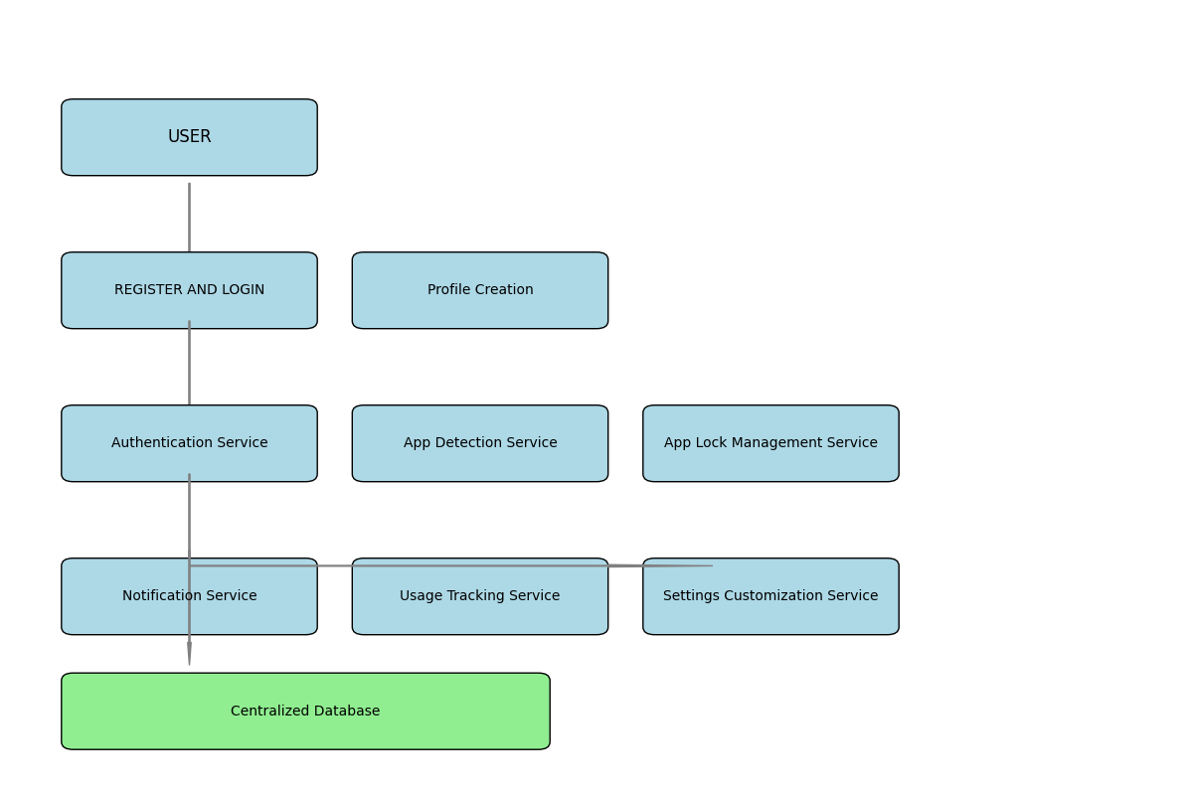

Figure 2.4 System Architecture Diagram

2.1.3.3. Data Exchange Contract

Frequency of Data Exchanges: Data exchanges in the App Lock project are designed to optimize performance and ensure timely access to critical information:

* Real-Time Exchanges: For essential operations like user authentication, app locking/unlocking actions, and access attempt notifications, data is exchanged in real-time via APIs to provide immediate feedback to the user and ensure seamless operation.
* Periodic Syncs: Non-critical data, such as usage history, access logs, and activity reports, is synchronized at regular intervals (e.g., daily or weekly), reducing network load while maintaining up-to-date tracking information for users.

Data Sets: The App Lock platform handles several key data sets, each with specific exchange requirements:

* User Data: Contains personal details, authentication credentials, and user preferences. This data is exchanged during login, profile updates, and security setting adjustments.
* App Data: Information about detected gambling apps, including app names and identifiers, exchanged during app detection scans and updates to ensure users have an accurate list of apps to lock.
* Usage Data: Includes data on access attempts, usage patterns, and historical usage statistics, which are exchanged periodically to update the user’s activity history and generate reports.

Mode of Exchanges (API, File, Queue, etc.): Various methods are used for data exchange across the App Lock platform:

* API: RESTful APIs handle real-time exchanges between the app’s front-end and back-end services for tasks like authentication, app locking, and notifications.
* Message Queues: Asynchronous services like RabbitMQ or AWS SQS manage background tasks, such as sending access notifications and processing activity logs, ensuring efficient performance without interrupting the user experience.
* File-Based Exchanges: Certain data, such as bulk data exports for detailed usage reports, are handled via file exchanges and stored securely on cloud storage like AWS S3, allowing users to access comprehensive activity data when needed

**2.1.4 UI DESIGN**

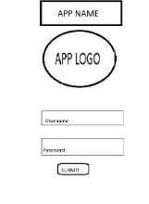

Figure 2.5 UI Design for Landing page

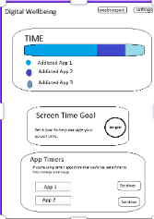

Figure 2.6 UI design for login page

**2.1.5 Functional Test Cases**

Table 2.3 Detailed Functional Test Case

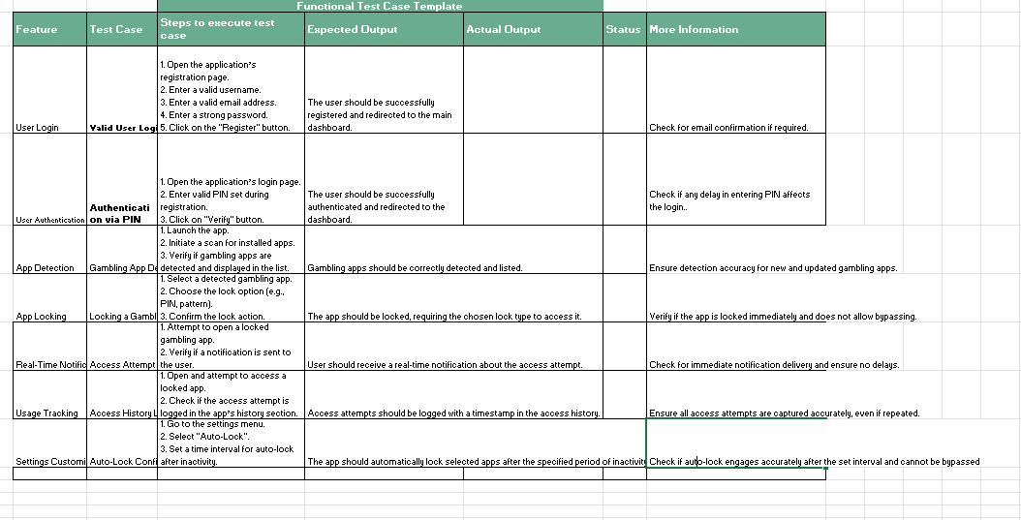

**2.1.6 Daily Call Progress**

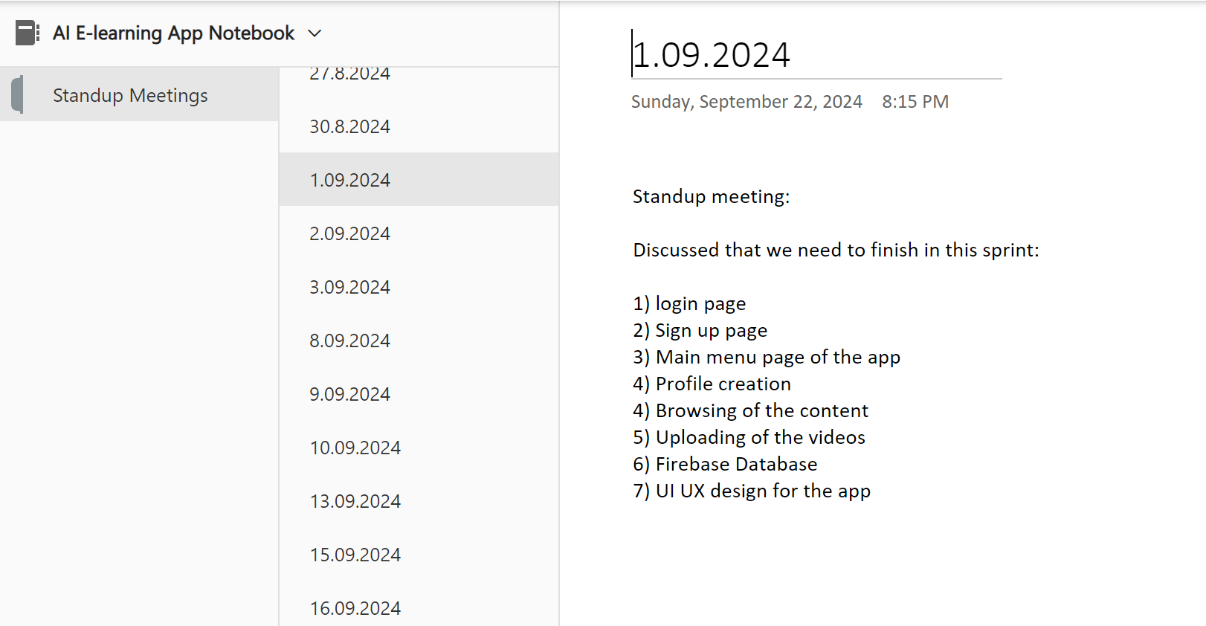

Figure 2.7 Standup meetings

**2.1.7 Committed Vs Completed User Stories**

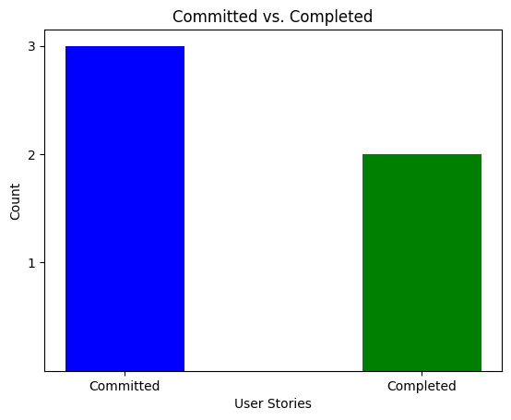

Figure 2.8 Bar graph for Committed Vs Completed User Stories

**2.1.8 Sprint Retrospective**

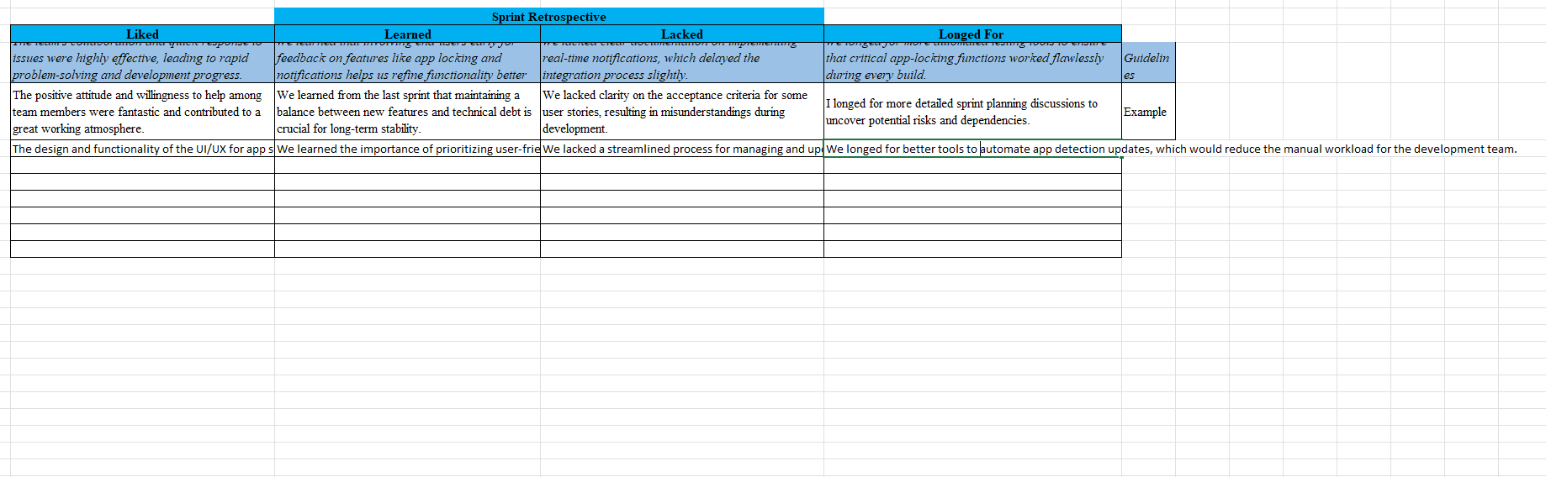

Figure 2.9 Sprint Retrospective for the Sprint 1

**CHAPTER 3**

**RESULTS AND DISCUSSION**

**3.1 Project Outcomes**

**The App Lock project successfully developed a user-friendly application aimed at helping individuals manage and control their usage of gambling apps. Key outcomes include:**

1. **Effective App Locking Mechanism: The app provides users with multiple locking options, including PIN, pattern, and biometric authentication, ensuring secure access control over gambling applications.**
2. **Real-Time Notifications: Users receive instant notifications upon any attempt to access locked gambling apps, keeping them aware of their usage habits and promoting mindful behavior.**
3. **Comprehensive Usage Tracking and Reporting: The app logs access attempts and provides users with weekly and monthly reports on their gambling app usage patterns, supporting self-awareness and helping users make informed decisions.**
4. **Customizable Settings for Personalization: Users have control over notification preferences, automatic re-locking, and lock durations, allowing them to tailor the app experience to their specific needs and habits.**
5. **Enhanced Digital Wellbeing: By providing effective app-locking and tracking tools, the App Lock project contributes to improved digital wellbeing, supporting users in their efforts to reduce compulsive app usage and manage gambling habits.**
6. **Positive User Feedback and Adoption: Initial user feedback highlighted the app's ease of use and effectiveness, particularly the intuitive UI and responsive functionality. The app demonstrated potential for high adoption among users seeking digital wellbeing tools.**

**3.2 Committed Vs Completed User stories**

**(SAMPLE)**

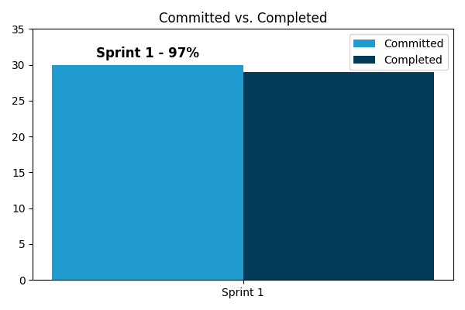

**CHAPTER 4**

**CONCLUSION & FUTURE ENHANCEMENTS**

**Here is a suggested **Conclusion** and **Future Enhancements** section for your **App Lock Project** aimed at managing gambling addiction:**

**---**

**### Conclusion**

**The App Lock Project was designed to help individuals manage gambling addiction by monitoring and blocking access to gambling websites and apps. This tool provides users with a proactive and supportive environment, allowing them to restrict access to potentially harmful content while also providing insights into their app usage behavior. Through a seamless integration of monitoring and blocking functionalities, the app serves as a valuable companion for individuals striving to take control of their online activities and foster healthier digital habits. By combining these tools with an intuitive user interface, the App Lock project offers an accessible and practical solution for managing and curbing gambling addiction.**

**### Future Enhancements**

**To further support users in their journey towards digital well-being, several enhancements can be integrated into the App Lock Project:**

**1. **Customizable Blocking Schedules\*\***

**Allow users to set personalized blocking schedules, specifying times of day when access to gambling sites is restricted. This customization can cater to individual needs and routines, reinforcing control over their online behavior.**

**2. **Enhanced Analytics and Insights\*\***

**Provide more detailed insights and analytics, such as trends in app usage over time, most accessed gambling apps or websites, and specific hours with high gambling app activity. This data could help users understand patterns in their behavior and progress in managing their addiction.**

**3. **Supportive Reminders and Motivational Messaging\*\***

**Introduce reminders and motivational messages aimed at reinforcing positive behavior and encouraging continued use of the app. Regularly providing supportive messages can help users stay motivated and remind them of their goals.**

**4. **Integration with Mental Health Resources\*\***

**Add links or suggestions for mental health resources, such as support groups, counseling services, or hotlines. This could make the app a more holistic support tool by providing users with immediate access to further help if they need it.**

**5. **Password Protection for Settings and App Deactivation\*\***

**Implement password protection or a delay mechanism for disabling or changing the app’s settings. This would prevent impulsive disabling and provide an additional layer of control, helping users stay committed to their goals.**

**6. **Progress Tracking and Goal Setting\*\***

**Allow users to set specific goals, such as reducing the number of times they access gambling apps per week, and track their progress over time. Gamified elements, like achievement badges, could also reinforce positive behavior and provide an encouraging experience.**

**7. **Family and Friends Support Feature\*\***

**Include a feature where trusted family members or friends can receive notifications or weekly summaries (with user consent) to offer encouragement and accountability support.**

**8. **Multi-Language Support\*\***

**Expand the app’s accessibility by incorporating multi-language support, allowing non-English speaking users to benefit from the app’s features, making it more inclusive and impactful.**

**By continuously enhancing and adapting the App Lock project to better meet user needs, the app can become an increasingly effective tool for those committed to overcoming gambling addiction and fostering digital well-being.**

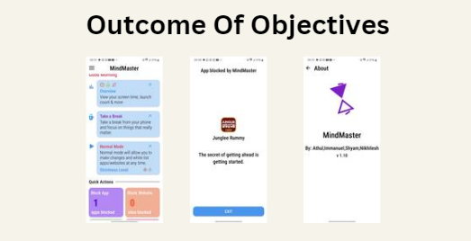

**APPENDIX**

* 1. **PATENT DISCLOSURE FORM**
  2. **SAMPLE CODING**

To detect running apps, you need to declare some permissions in the AndroidManifest.xml:

xml

Copy code

<manifest ...>

<uses-permission android:name="android.permission.PACKAGE_USAGE_STATS"/>

<uses-permission android:name="android.permission.SYSTEM_ALERT_WINDOW"/>

<application ...>

<!-- Add other components here -->

</application>

</manifest>

**2. UsageStatsManager for Monitoring App Usage**

In Android, you can use the UsageStatsManager to monitor and detect active apps.

**Sample Code for Monitoring and Blocking Apps**

Here's a simple setup where the app detects if a certain app (e.g., a gambling app) is running and then blocks access by displaying an overlay.

**MainActivity.kt**

kotlin

Copy code

import android.app.AppOpsManager

import android.app.usage.UsageEvents

import android.app.usage.UsageStatsManager

import android.content.Context

import android.content.Intent

import android.os.Bundle

import android.provider.Settings

import android.widget.Toast

import androidx.appcompat.app.AppCompatActivity

class MainActivity : AppCompatActivity() {

// List of apps to block

private val blockedApps = listOf("com.example.gamblingapp")

override fun onCreate(savedInstanceState: Bundle?) {

super.onCreate(savedInstanceState)

setContentView(R.layout.activity_main)

// Check for usage permission and request if not granted

if (!hasUsagePermission()) {

requestUsagePermission()

} else {

// Start the AppMonitorService to monitor app usage

startService(Intent(this, AppMonitorService::class.java))

}

}

private fun hasUsagePermission(): Boolean {

val appOps = getSystemService(Context.APP_OPS_SERVICE) as AppOpsManager

val mode = appOps.checkOpNoThrow(

AppOpsManager.OPSTR_GET_USAGE_STATS,

android.os.Process.myUid(), packageName

)

return mode == AppOpsManager.MODE_ALLOWED

}

private fun requestUsagePermission() {

Toast.makeText(this, "Please grant usage access permission", Toast.LENGTH_LONG).show()

startActivity(Intent(Settings.ACTION_USAGE_ACCESS_SETTINGS))

}

}

**AppMonitorService.kt**

This service will continuously monitor the active app and block access to any apps in the blockedApps list.

kotlin

Copy code

import android.app.Service

import android.app.usage.UsageEvents

import android.app.usage.UsageStatsManager

import android.content.Context

import android.content.Intent

import android.os.Handler

import android.os.IBinder

import android.widget.Toast

class AppMonitorService : Service() {

private val blockedApps = listOf("com.example.gamblingapp")

private lateinit var usageStatsManager: UsageStatsManager

private val handler = Handler()

override fun onCreate() {

super.onCreate()

usageStatsManager = getSystemService(Context.USAGE_STATS_SERVICE) as UsageStatsManager

startAppMonitoring()

}

private fun startAppMonitoring() {

handler.postDelayed(object : Runnable {

override fun run() {

val currentApp = getForegroundApp()

if (blockedApps.contains(currentApp)) {

showBlockedOverlay()

}

handler.postDelayed(this, 1000) // Check every second

}

}, 1000)

}

private fun getForegroundApp(): String? {

val endTime = System.currentTimeMillis()

val startTime = endTime - 1000 * 60

val usageEvents = usageStatsManager.queryEvents(startTime, endTime)

var lastApp: String? = null

while (usageEvents.hasNextEvent()) {

val event = UsageEvents.Event()

usageEvents.getNextEvent(event)

if (event.eventType == UsageEvents.Event.MOVE_TO_FOREGROUND) {

lastApp = event.packageName

}

}

return lastApp

}

private fun showBlockedOverlay() {

val overlayIntent = Intent(this, BlockedOverlayActivity::class.java)

overlayIntent.addFlags(Intent.FLAG_ACTIVITY_NEW_TASK)

startActivity(overlayIntent)

}

override fun onBind(intent: Intent?): IBinder? {

return null

}

}

**BlockedOverlayActivity.kt**

This activity will display an overlay screen whenever a blocked app is launched.

kotlin

Copy code

import android.os.Bundle

import android.view.WindowManager

import androidx.appcompat.app.AppCompatActivity

class BlockedOverlayActivity : AppCompatActivity() {

override fun onCreate(savedInstanceState: Bundle?) {

super.onCreate(savedInstanceState)

setContentView(R.layout.activity_blocked_overlay)

// Make the activity appear over the blocked app

window.setType(WindowManager.LayoutParams.TYPE_APPLICATION_OVERLAY)

}

override fun onBackPressed() {

// Prevents the back button from exiting this overlay

moveTaskToBack(true)

}

}

**activity_blocked_overlay.xml**

Design a simple overlay layout with a message for the blocked app screen:

xml

Copy code

<RelativeLayout xmlns:android="http://schemas.android.com/apk/res/android"

android:layout_width="match_parent"

android:layout_height="match_parent"

android:background="@android:color/holo_red_dark">

<TextView

android:id="@+id/blocked_message"

android:layout_width="wrap_content"

android:layout_height="wrap_content"

android:layout_centerInParent="true"

android:text="This app is blocked!"

android:textColor="@android:color/white"

android:textSize="24sp" />

</RelativeLayout>

**Explanation:**

1. **Permissions**: The app requests PACKAGE_USAGE_STATS to detect the currently running app and SYSTEM_ALERT_WINDOW to display overlays.
2. **MainActivity**: Starts AppMonitorService if permission is granted.
3. **AppMonitorService**: Uses UsageStatsManager to detect the current foreground app and checks if it’s in the blockedApps list. If it’s blocked, it launches BlockedOverlayActivity.
4. **BlockedOverlayActivity**: Shows an overlay with a blocking message, preventing the user from interacting with the blocked app.

This is a basic setup that should give you a foundation for creating your App Lock functionality.

* 1. **PLAGIARISM REPORT**